Advanced Shell Simulation with Integrated OS Concepts

Group 4:
Abdul Rahim Aamir
Ebubechukwu Ohizu
Gaurab Karki
Rajiv Agrawal

An assignment submitted in partial fulfillment of the requirements for MSCE-631 as part of
In
Cyber Engineering

School of Computing and Information Sciences
University of the Cumberlands
MSCE-630: Advanced Operating Systems
Dr. Primus Vekuh
March 28, 2026

Spring 2026

Pipes, Security, and System Integration
1. Integration Overview
Deliverable 4 brings all four OS concepts together into a single, cohesive shell. The architecture is a layered dispatcher: authentication gates entry, the REPL loop parses and routes commands, and security checks intercept file-touching operations before they reach built-ins.
Component Map
Component | Module | Integrated In
Process Management | shell/process_manager.py | main.py dispatcher
Scheduling | shell/scheduler.py | main.py dispatcher (schedule / add-task / run-scheduler)
Memory Management | shell/memory_manager.py | main.py dispatcher (mem-*)
Synchronization | shell/synchronization.py | main.py dispatcher (mutex-* / sem-* / run-*)
Piping | shell/pipe_handler.py | main.py — replaces the D1–D3 stub
Security | shell/security.py | main.py — login on startup, check before every file command

All modules share state through module-level singletons: security._current_user/role, scheduler._active_scheduler, memory_manager._mem. No global mutable state is passed between functions as arguments; each module manages its own lifecycle.

2. Piping Implementation
Piping is implemented in shell/pipe_handler.py using subprocess.Popen.
Pipeline Construction
1. parser.parse() splits the input line on | and returns a list[list[str]] where each sub-list is one command segment.
2. main.py detects is_pipe=True and delegates to run_pipeline(commands).
3. run_pipeline() iterates over segments left-to-right:
For all but the last segment, stdout=subprocess.PIPE captures output as a readable stream.
For the last segment, stdout=None so output flows directly to the terminal.
Each process's stdin is set to the previous process's stdout pipe object.
After spawning each child, the parent immediately closes its copy of the read end of the pipe (prev_proc.stdout.close()). This is critical: without this, sort and similar commands that wait for EOF will hang forever because the parent still holds an open file descriptor.
4. After spawning all processes, the parent calls proc.wait() on each, collecting exit codes and preventing zombies.

Error Handling and File Descriptor Discipline
FileNotFoundError → 'command not found' message; all already-started processes are killed.
PermissionError → 'permission denied' message; same cleanup.
Background pipelines (cmd1 | cmd2 &) skip the wait loop and print a status message.
The key invariant is: every file descriptor is owned by exactly one process at a time. The parent transfers ownership of each pipe's read end to the next child by passing stdin=prev_proc.stdout, then immediately closes its own copy. This avoids both fd leaks and the classic 'pipeline hangs at EOF' bug.

3. Security Mechanisms
User Authentication
The login flow (security.login()) is called once from main() before the REPL starts:
1. Prompts for username and password (up to 3 attempts).
2. Looks up the username in data/users.json.
3. Calls _verify_password(stored_hash, salt, entered_password):
Recomputes SHA-256(salt + entered_password).
Compares with hmac.compare_digest() — a timing-safe comparison that prevents timing-based side-channel attacks (an attacker cannot learn whether the hash prefix matched by measuring response time).
4. On success, sets _current_user and _current_role module globals. On 3 consecutive failures, calls sys.exit(1).
Password storage: data/users.json stores only {hash, salt, role} — never plaintext. A fresh 16-byte random salt (secrets.token_hex(16)) is generated for each user entry, preventing rainbow-table attacks.

Role-Based Access Control
Two roles control what operations are permitted:
Operation | admin | user
All file reads | ✅ | Default: ✅ (unless denied in permissions.json)
All file writes | ✅ | Default: ❌ (unless granted in permissions.json)
useradd | ✅ | ❌ — 'permission denied (admin only)'
chmod | ✅ | ❌ — 'permission denied (admin only)'

check_permission(path, op) is called in main.py before dispatching cat, ls, rm, touch, mkdir, rmdir. Admins always pass. For standard users the lookup proceeds through data/permissions.json.

File Permissions
data/permissions.json stores per-path entries with role-based permission strings (any combination of r, w, x or --- to deny all). check_permission(path, op) proceeds as follows:
1. If role == 'admin' → return True immediately.
2. Look up the path in permissions.json (exact match, then os.path.normpath match).
3. If no entry exists → default: 'r' allowed, write/execute denied.
4. If an entry exists → check whether op ('r', 'w', or 'x') appears in the user permission string.
chmod <path> <perms> (admin only) updates data/permissions.json in-place, persisting across sessions.

4. Challenges and Improvements
Challenges
1. File-descriptor ownership in pipelines: The classic 'pipeline hangs' bug — where sort waits indefinitely for EOF because the parent still holds the read end of the pipe — required carefully closing prev_proc.stdout in the parent immediately after passing it to the next child. This is subtle and not obvious from the subprocess documentation.
2. Timing-safe password comparison: A naive == comparison of password hashes is vulnerable to timing attacks. Using hmac.compare_digest ensures the comparison takes constant time regardless of where a mismatch occurs.
3. Bootstrapping data files: The data/users.json and data/permissions.json files must exist before login. The _bootstrap_* functions create them with default accounts and entries if they are absent, enabling the shell to run in a fresh clone without a manual setup step.
4. Integrating security checks without modifying built-ins: Rather than adding check_permission calls inside each built-in function (which would couple builtins.py to security.py), the permission check is placed in main.py immediately before dispatching to BUILTINS[cmd]. This keeps each module single-purpose.
5. Pipe support for built-in commands: Built-in commands (e.g., ls, cat) run in the same process and cannot have their stdout captured by subprocess.PIPE. For this simulation, piping is restricted to external executables. Fully supporting built-ins in pipelines would require forking the shell process or redirecting sys.stdout — a significant complexity increase left for future work.

Potential Improvements
Add a sudo command that temporarily elevates a user to admin for a single command after re-entering their password.
Implement getent passwd-style user listing with a users command.
Support piping from/to built-in commands by capturing their sys.stdout output into a io.StringIO buffer and feeding it as stdin to the next subprocess.
Add an audit log that records every command executed, the user, timestamp, and outcome — addressing the OWASP 'Security Logging and Monitoring Failures' control.
Store data/users.json with file-system permissions (chmod 600) so only the shell process owner can read it.

5. Screenshots
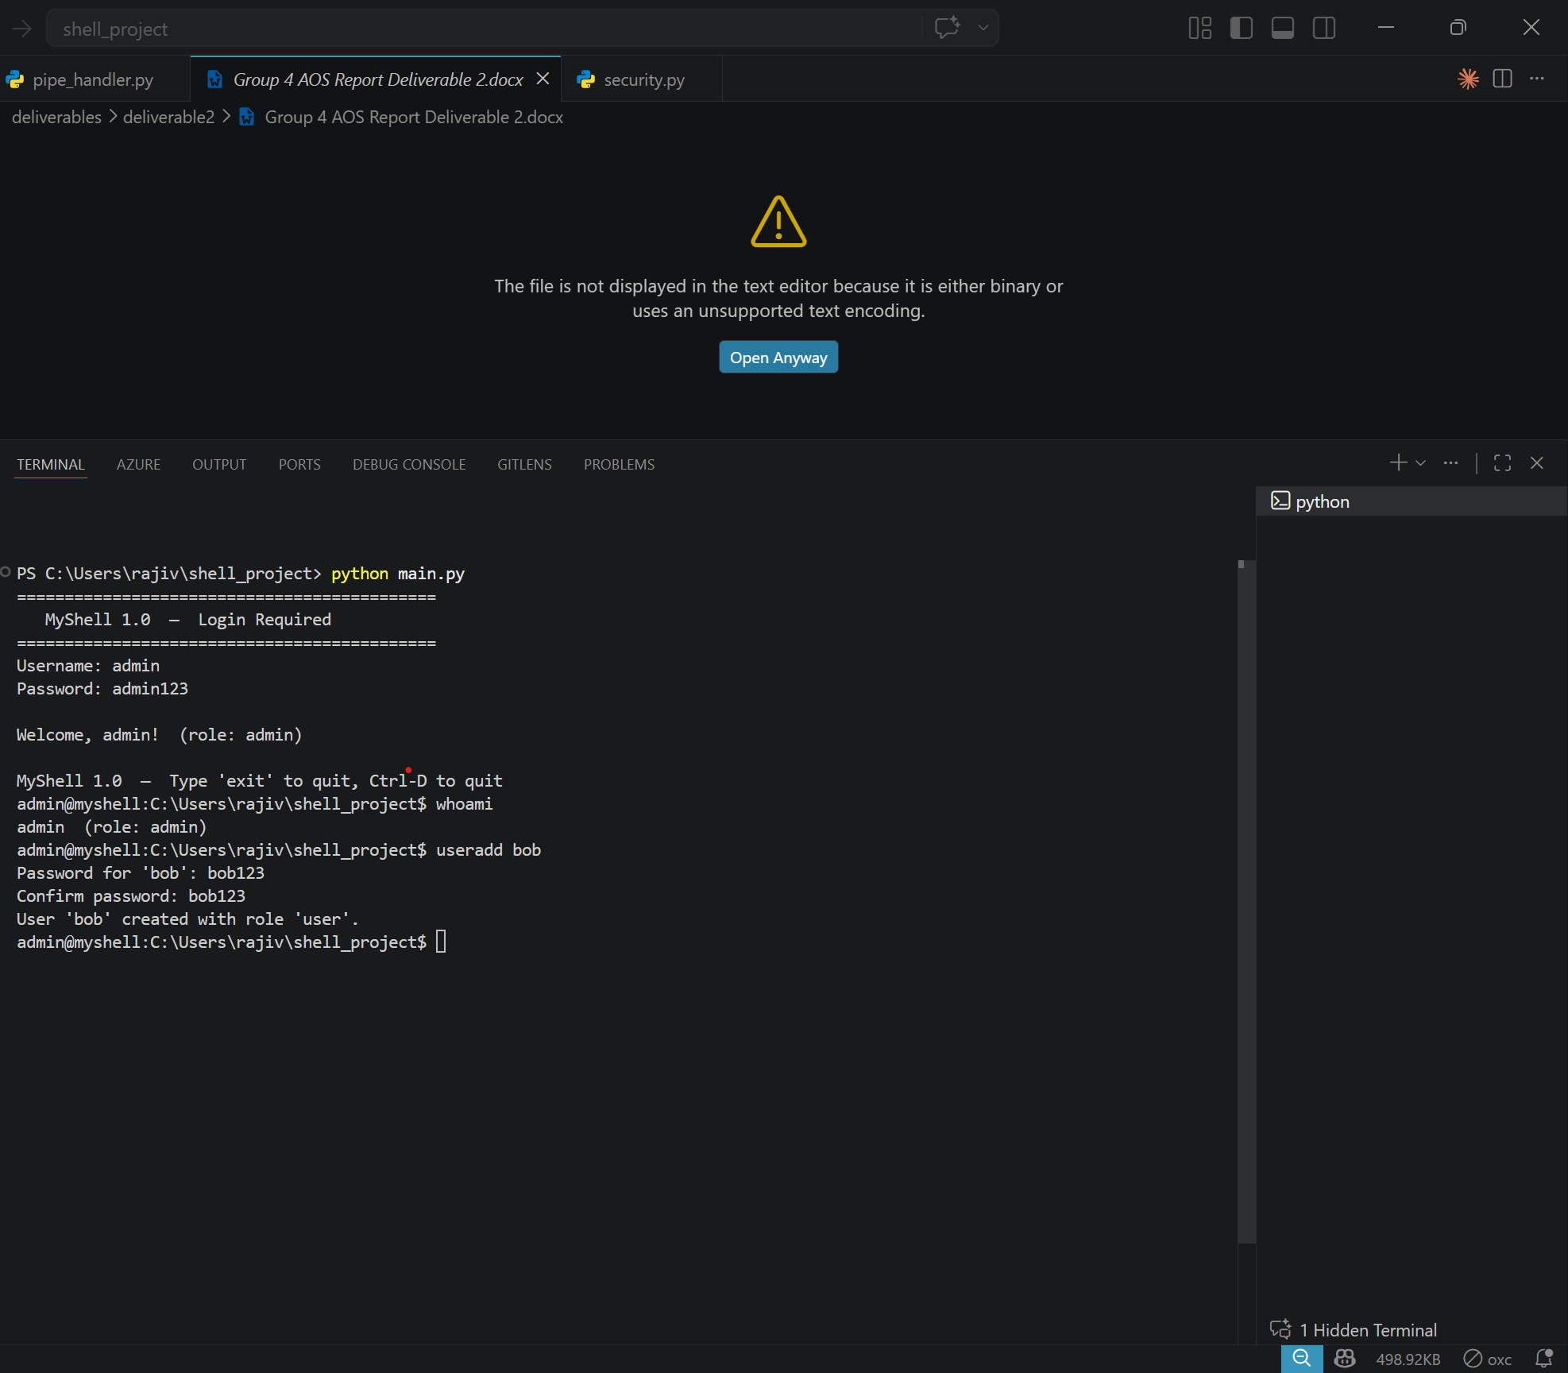
Figure 1: Login and Authentication — secure login prompt with role display

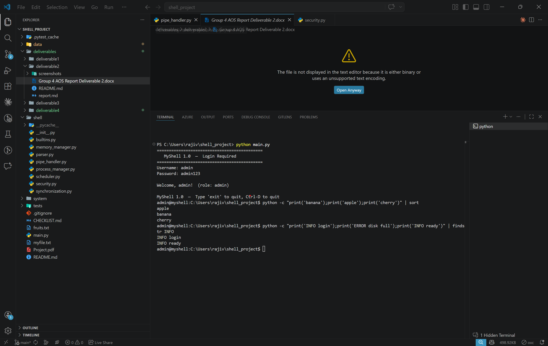
Figure 2: Pipe Command Execution — chaining commands with | operator

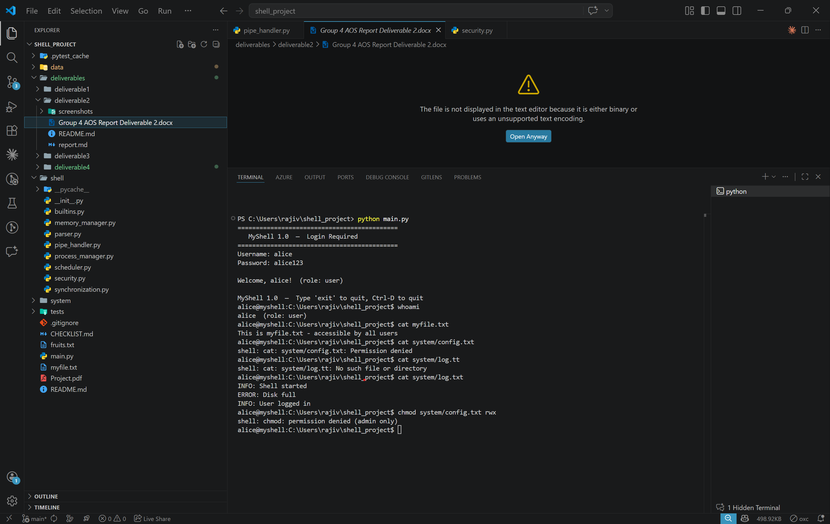
Figure 3: RBAC Permission Enforcement — access denied for unauthorized operations

University of the Cumberlands
School of Computing and Information Sciences

Certification of Authorship
Submitted to: Dr. Primus Vekuh
Course: MSCE-630
Students’ Name: Abdul Rahim Aamir, Ebubechukwu Ohizu, Gaurab Karki, Rajiv Agrawal
Date of Submission: 03/28/2026
Purpose and Title of Submission: Pipes, Security, and System Integration

Certification of Authorship: I hereby certify that I am the author of this document and that any assistance I received in its preparation is fully acknowledged and disclosed in the document. I have also cited all sources from which I obtained data, ideas, or words that are copied directly or paraphrased in the document. Sources are properly credited according to accepted standards for professional publications. I also certify that this paper was prepared by Group 4 for this purpose.

